|  |  |
| --- | --- |
| **Logo_FPT_University_doc** | **MINISTRY OF EDUCATION AND TRAINING** |

|  |
| --- |
| **FPT UNIVERSITY** |
| Capstone Project Document |
| E-learning website |
|  |
| |  |  | | --- | --- | | **Unicorn** | | | **Group Members** | |  |  |  | | --- | --- | --- | | -NguyễnTuấn Minh | 01135 | Leader | | -NguyễnHồng Nam | 00903 | Member | | -NguyễnTiếnHuy | 01016 | Member | | - Nguyễn Minh Hiếu | 00684 | Member | | -NguyễnTrườngHưng | 00838 | Member | | | **Supervisor** | NguyễnTấtTrung | | **Ext Supervisor** | HuỳnhAnhDũng | | **Capstone Project code** | E-learning | |
|  |

|  |
| --- |
| Hanoi,29 July 2012 |

Record of change

\*A - Added M - Modified D - Deleted

|  |  |  |  |  |
| --- | --- | --- | --- | --- |
| Effective Date | Changed Items | A\* M, D | Change Description | New Version |
| 15/5 | Create new | A |  | V1.0 |
|  |  |  |  |  |
|  |  |  |  |  |
|  |  |  |  |  |
|  |  |  |  |  |
|  |  |  |  |  |
|  |  |  |  |  |
|  |  |  |  |  |
|  |  |  |  |  |
|  |  |  |  |  |
|  |  |  |  |  |
|  |  |  |  |  |
|  |  |  |  |  |
|  |  |  |  |  |
|  |  |  |  |  |
|  |  |  |  |  |
|  |  |  |  |  |
|  |  |  |  |  |
|  |  |  |  |  |
|  |  |  |  |  |
|  |  |  |  |  |

TABLE OF CONTENTS

[1.BACKGROUND 4](#_Toc521322905)

[2.purpose 4](#_Toc521322911)

[3.literature review 4](#_Toc521322912)

[3.1Overview of existing system 4](#_Toc521322913)

[3.2Achievements of existing system 7](#_Toc521322914)

[3.3Limitation of existing system 7](#_Toc521322915)

[4.idea 7](#_Toc521322925)

4.1 Home page “Trang chủ”………………….…………………….…..…………………………………….8

4.2 News “Tin tức” ………………………………….………………….….….………………………………….8

4.3 Theories “Lý thuyết” ……………………………………………..…..……………………………………8

4.4 Exercice“Thư viện bài tập” ………………………….….……………………………………………..9

4.5 Self-study exams “Đề tự luyện”…………….………..….………………………………………..…9

4.6 Exam online “Thi trực tuyến” ………….………………….………………………………………….10

4.7 Forum “Diễn đàn” …………………………………….…...…………..………………………………… 10

4.8 Member “Thành viên” ……………………..………………. ..……………………………..………….10

**5.PROPOSAL…………………………………… ………………………………… 11**

5.1 Sites……………………………… …………..………………… ……..………………………………………… 11

5.2 Main functions……………….…………………………………… … ………………………………………12

5.3 Some other functions…………….……………………………………………….………………………..13

**6.Reference…………………………………………………………………………………14**

I> Report No.1: Introduction

# 1 – Background

Nowadays, e-learning has become commonly in many countries around the world. In Vietnam, with the development of Internet, e-learning is really necessary to students to get more flexible, convenient… in receiving knowledge.

Simpler than going to school or somewhere in which students must pay fee, they only need to have a computer which connected to internet, they don’t need to go anywhere and learning cost will be cheaper if they study online. They can get more information, materials about special subject. For example, a student wants to learn trigonometry in grade 11, beside some theory from text book, he can get some interesting information about history of trigonometry from Wikipedia. He also finds out many forms of exercises (with solutions or not) to train himself.

# 2 – Purpose

This website is created to meet two goals:

* Complete the capstone project of FPT-University.
* Create an e-learning website that can support Vietnamese students in learning, reviewing…

# 3 – Literature review

## 3.1 Overview of existing system

In this chapter, we will show some e-learning websites that are available in Vietnam. Each of them has some advantages and disadvantages. So you can understand clearly about the development of e-learning in Vietnam. They Include:

* *hocmai.vn*
* *moon.vn*
* Some other websites: *truongvietnam.vn*, *onthionline.net*, *truongtructuyen.vn,thaytro.vn*…

We will analyze two websites: *hocmai.vn* and *moon.vn* because they are websites which are familiar and popular.

* **hocmai.vn**

This website was established in 2007. Nowadays it is the biggest e-learning forum in Vietnam. It makes profit by selling more than 2000 videos, courses which are built and taught by famous experience teachers.

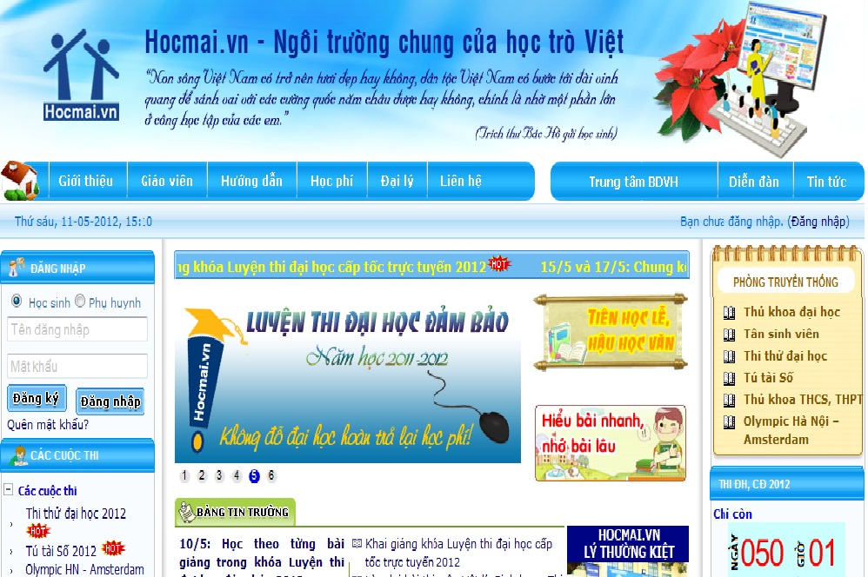

Figure 1.1Hocmai’sWebsite[1]

* **Advantages:**
* Essence of hocmai.vn is a forum that help student share and exchange knowledge about subjects (math, literature, English…).
* *hocmai.vn* has more than 2000 videos about courses. Student can learn online by watching these video and theory files with .pdf extension.
* With *hocmai.vn*, not only students but also their parents can log in and watch for learning of students.
* **Disadvantages:**
* The databases of hocmai.vn focus on videos of courses to make profit. So its exercises, theories are updated rarely.

[1]<http://hocmai.vn/>

* Forum of *hocmai.vn* is very large with many subjects of many grades. So it is difficult to use, manage, update.
* *hocmai.vn* is used for advertising of offline learning operation. So it does not focus on e-learning completely.
* **moon.vn**

This website is established in 2008. It makes profit by focusing on selling examination products. Most of exercises on moon.vn are multiple choices.

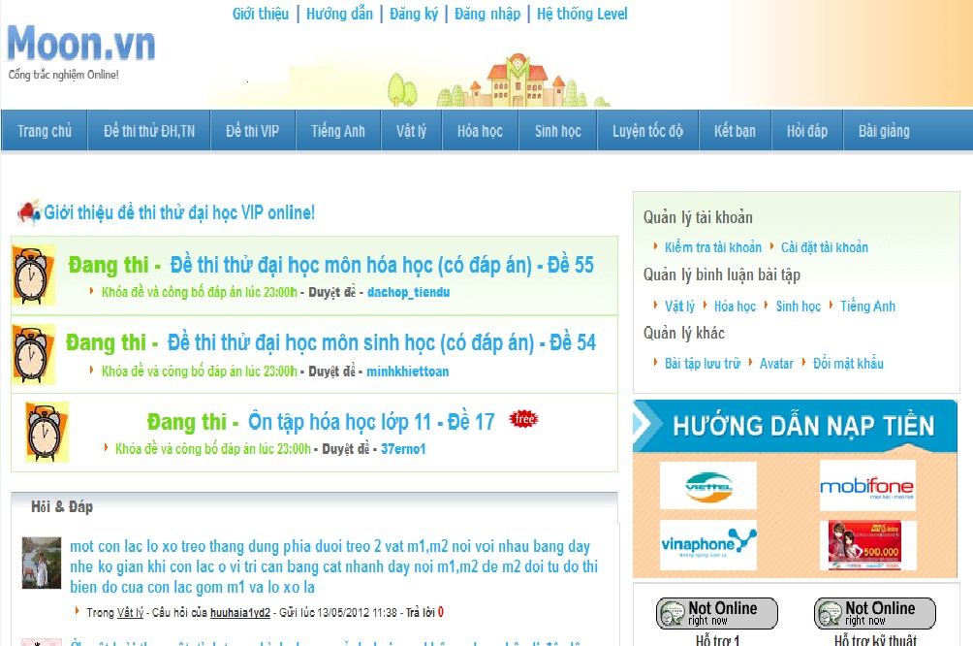

Figure 1.2 Moon’s Website[2]

* **Advantages:**
* *moon.vn* focus on examination. So that, its functions support taking exam online.
* Site “Hỏi đáp” is a small forum. It helps students give questions and take answers easier and fast.
* User ranking function “hệ thống level” creates competition between students.
* User (teachers) can give questions, exercises, exams to *moon.vn* to get money in return.

[2]<http://www.moon.vn/Home1/>

* The function “Đấu trường” is a special attraction of *moon.vn*. Students can make groups and compete together in “Đấu trường”.
* **Disadvantages:**
* The databases of *moon.vn* have been taken from many sources in internet at beginning. So that it is not updated regularly.
* *moon.vn* does not have own good teacher. It also does not have a function to guarantee quality of exercises.
* *moon.vn* does not have many subjects. It just focuses on some important subjects (math, English, chemistry…).

## 3.2 Achievements of the existing system

* Big e-learning websites focus on making profit. So they have functions for selling online education products.
* Students have many choices for e-learning:
  + Sharing, exchanging knowledge through forums with support of teachers or senior members.
  + Join in special operation like “Đấu trường” of *moon.vn*.
  + Learning through watching videos like truongtructuyen.vn or *hocmai.vn*.

## 3.3 Limitations of existing system

* Small e-learning websites can support free users. But these websites is not developed carefully. These sites are places for some groups of students sharing knowledge, not for all kinds of student.
* Most of databases depend on administrators of websites. So that it is difficult to update or updated slowly.
* There is not a website which supports requirements from many kinds of user. Example: members of *moon.vn* easy to do exams but difficult to learn theories structurally; members of *hocmai.vn* usually learn through videos by paying fee, so free users rarely join in *hocmai.vn*.

# 4 – Idea

The goal of this project is an e-learning website that supports many kinds of user with many kinds of requirements. It is expected to overcome disadvantages of available e-learning websites. This chapter shows some features that can be developed in this capstone project.

This website has following sites:

## 4.1 Home page “Trang chủ”

This site is designed friendly, simple and easy to use. It has some beginning divisions: Logo, banner and slogan, menu bar, hot topics, news, login form, search bar, subjects (divide by grades or by topics – this will be described later in this chapter) and some other information.

Menu bar include links to other sites. This menu is common to other sites of this website:

* Home page “Trang chủ”
* News “Tin tức”
* Theories “Lý thuyết”
* Exercises “Thư viện bài tập”
* Self-study exams “Đề tự luyện”
* Exam online “Thi trực tuyến”
* Forum “Diễn đàn”
* Member “Thànhviên”

***Main functions*:** Login, link to other sites, show some main information: hot topics, subjects…

## 4.2 News “Tin tức”

This site includes some news about education: Information of schools, Information of entrance exam, university ranking…

***Main function:*** Show news.

## 4.3 Theories “Lý thuyết”

This site provides theories of subject with two kinds: grade and topic.

* **Grade theory:**
* When a student chooses this, he can learn basic theories depend on which grade he is in. Example, student Nguyen Tuan Minh (grade 11) wants to learn geometry, he can chooses “Lý thuyết” site => Grade 11 “Lớp 11” =>Subject math “Toán” => Geometry “Hình học”. After that, he can learn theories about geometry of grade 11 and get some refer exercises below.
* Grade theory is developed to focus on supporting students who want to learn new knowledge.
* **Topic theory:**
* When a student chooses this, he can learn collective theories about concrete topic. Example, student Nguyen Hong Nam (grade 12) wants to learn knowledge about organic chemistry that collected from three grades (10,11,12), he can chooses “Lý thuyết” site => Topic “Chuyên đề” => Subject chemistry “Môn hóa” => Organic chemistry “Hóa hữu cơ”. After that, he can learn theories about organic chemistry collectively and get some refer exercises below.
* Topic theory is developed to focus on supporting students who want to take university exams.

***Main function:*** Show theories and knowledge of subjects and refer exercises.

## 4.4 Exercise “Thư viện bài tập”

This site provides many kinds of exercises, questions and answers for students. Exercise can be divided by grades, subjects or students can do collective knowledge exercise here. It is different from theories site in which, students just can do basic and simple exercises.

***Main functions:***

* Show exercises from databases. Students can do multiple choice exercises by tick answers.
* Students can choose level of exercises (from simple to difficult) and estimate level of an exercise.

## 4.5 Self-study exams “Đề tự luyện”

This site provides many kinds of exams for students.

To do an exam, students can choose exam from library of the system. There is a built examination library that includes many exams of many subjects. Students can choose one of them to self-study. An exam has some important attributes: time, number of question, level of questions.

***Main function:*** Allow student choose exam’s attributes, show exam’s questions and time, count down and finish exam when user agree to finish or time up, show mark after user finish the exam.

## 4.6 Exam online “Thi trực tuyến”

Functions of this site are different from self-study exams.

In this site, administrators or people with authority can give special exams. These exams are informed before about start time, end time, number of questions. And when an exam is started, students can take the exam in beginning 15 minutes and like self-study exam. After exam finishes, mark of examinees will be sent to each student and some of them can take the next one (round 2,3,4…) if they have good mark. Exam can also be taken by group of users.

***Main functions:*** Show questions, time about exam; filter users to take next exam; support taking exam by group of users.

## 4.7 Forum “Diễn đàn”

This site is a forum in which, members can share and exchange knowledge about subjects, education information.

***Main function:*** Show topics, boxes like a normal forum.

## 4.8 Member “Thành viên”

This site helps a student manage individual information: e-mail, name, age, marks, birthday…

# 5 – Proposal

This chapter shows priorities of features in this capstone projects.

## 5.1 Sites

This website include to 8 sites:

|  |  |
| --- | --- |
| **Priority** | **Site** |
| 1 | Home page “Trangchủ” |
| 2 | Theories “Lýthuyết” |
| 3 | Exercise “Thưviệnbàitập” |
| 4 | Self-study exams “Đềtựluyện” |
| 5 | Forum “Diễnđàn |
| 6 | Member “Thànhviên” |
| 7 | News “Tin tức” |
| 8 | Exam online “Thitrựctuyến |

- Following sites are basics sites. So they must be done. Including to:

* Home page “Trang chủ”
* Theories “Lý thuyết”
* Exercise “Thư viện bài tập”
* Self-study exams “Đề tự luyện”
* Forum “Diễn đàn”
* Member “Thành viên”

- Following sites can be developed after above sites completed:

* News “Tin tức”
* Exam online “Thi trực tuyến”

## 5.2 Main functions

We will describe some main functions that are different from other e-learning websites here. These can be updates of basic function.

**5.2.1 Log in and register**

This website provides two ways for new member to register:

* Use open ID (account Facebook)
* Register directly in this website

**5.2.2 Exercise ranking**

Student can estimate the level (from simple to difficult)

**5.2.3 Databases updated by user**

This function is developed to allow users who have authority to input new exercises or knowledge into databases. This function help the website havedatabases that are updated regularly.

**5.2.4 Formula**

This function helps the website operate with storing, displaying formula of math, chemistry, and physics.

**5.2.4 Intelligent user identification**

This function helps students learn more easily in the website.

When a student login to the website, by some information, we can provide some suggestion to that user.

Example: When a student login to the website, he is grade 11. We get grade information and display subjects, topics relate to knowledge of grade 11 to him. So he can be easy to get what he wants. Besides, he also can get other options, he can do exercises of grade 10 if he wants, just click on grade 10 in “Exercise” site.

## 5.3 Some other functions

In this chapter, we list some functions that can be developed if we have enough time.

**5.3.1 Comment in comment**

In common forums, a comment can have a quotation of other comments. This is often inconvenient if a topic has many comments. This function is developed to help a user track his comment easily when every answers of his comment can be displayed in one form without quotation.

Following picture is an example of this function:

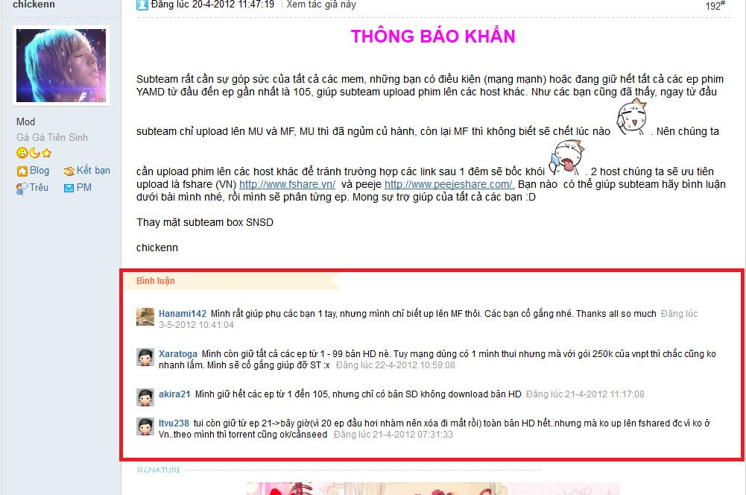

Figure 1.3 comment example[3]

**5.3.2 Exam online functions**

Functions refer to above exam online sites can be developed later.

[3]<http://kites.vn/thread/-kbs-2008-you-are-my-destiny-im-yoona-park-jaejung-vietsub-ep-103-105-sd-hd-completed--775-20-1.html>

# 6 – Reference

<http://hocmai.vn/>

<http://www.moon.vn/Home1/>

<http://truongtructuyen.vn/TrangChu.aspx>

<http://thaytro.vn>

<http://onthionline.net>

<http://kites.vn/thread/-kbs-2008-you-are-my-destiny-im-yoona-park-jaejung-vietsub-ep-103-105-sd-hd-completed--775-20-1.html>